Catholic Health Association of New Brunswick Scholarship Recipients

2010 RECIPIENTS

Eric Bowes- Anglophone Scholarship Recipient

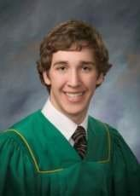

Veronic Martin- Francophone Scholarship Recipient

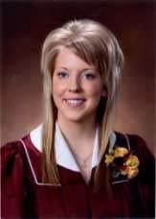

2011 RECIPIENTS

Emily Love- Anglophone Scholarship Recipient

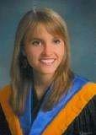

Melanie Cormier- Francophone Scholarship Recipient

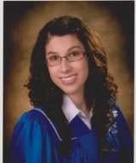
2012 RECIPIENTS

Kendra Breedveld – Anglophone Scholarship Recipient

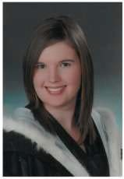

Vanessa Courty- Francophone Scholarship Recipient

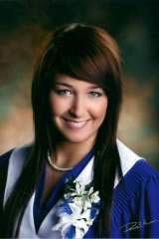

2013 RECIPIENTS

Marissa Gale- Anglophone Scholarship Recipient

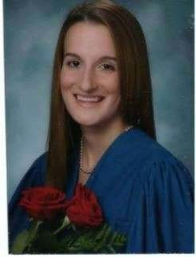

Julie Bedard – Francophone Scholarship Recipient

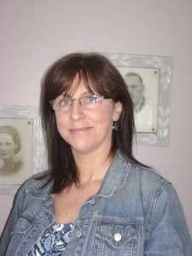

2014 Recipients

Allison Bowes- Anglophone Scholarship Recipient

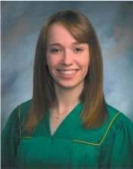

Geneviève Morneault – Francophone Scholarship Recipient

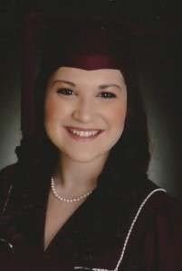

2015 Recipients

Nicole Johnston – Anglophone Scholarship Recipient

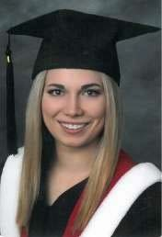

Olivier Savoie – Francophone Scholarship Recipient

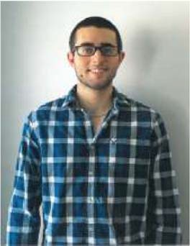

2016 Recipients

Melissa Gallant – Anglophone Scholarship Recipient

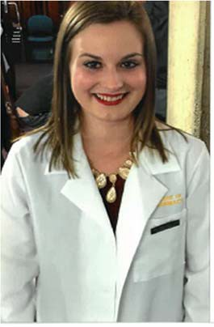

Dominique Mallet – Francophone Scholarship Recipient

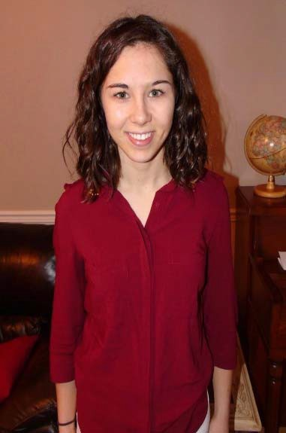

2017 Recipients

Julia Kyle – Anglophone Scholarship Recipient

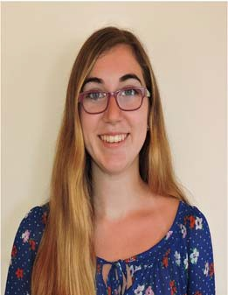

Vanessa Hyppolite – Francophone Scholarship Recipient

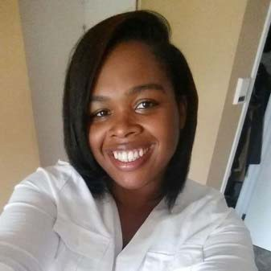

2018 Recipients

Jennifer White – Anglophone Scholarship Recipient

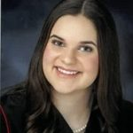

Julie LeBouthillier – Francophone Scholarship Recipient

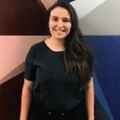

2019 Recipients

Abigail McFawn – Anglophone Scholarship Recipient

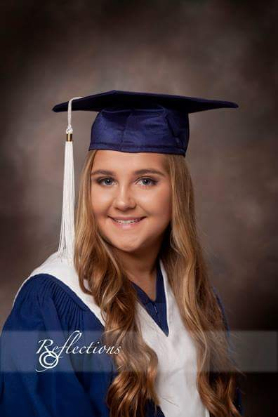

Marie-Christine Noël – Francophone Scholarship Recipient

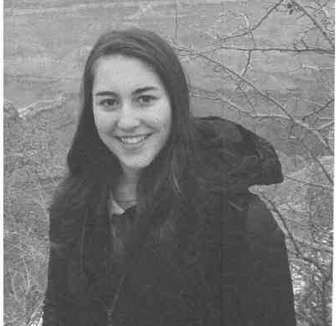

2020 Recipients

SooMin Park – Anglophone Scholarship Recipient

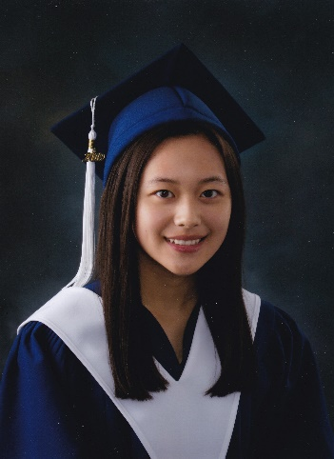

Anika Nastasuik – Anglophone Scholarship Recipient

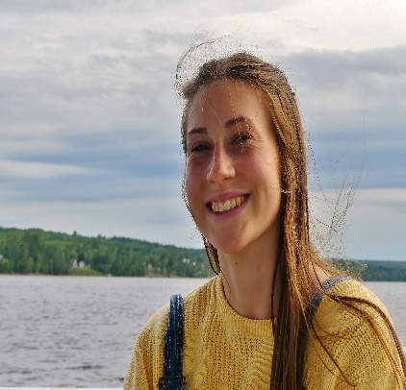

2020 Recipients

Sebastien Leblanc – Francophone Scholarship Recipient

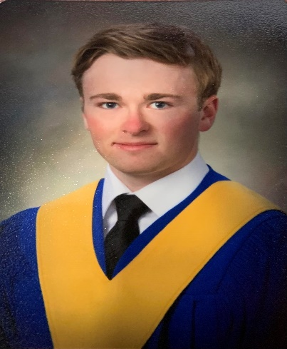

Sophie Despres – Francophone Scholarship Recipient

